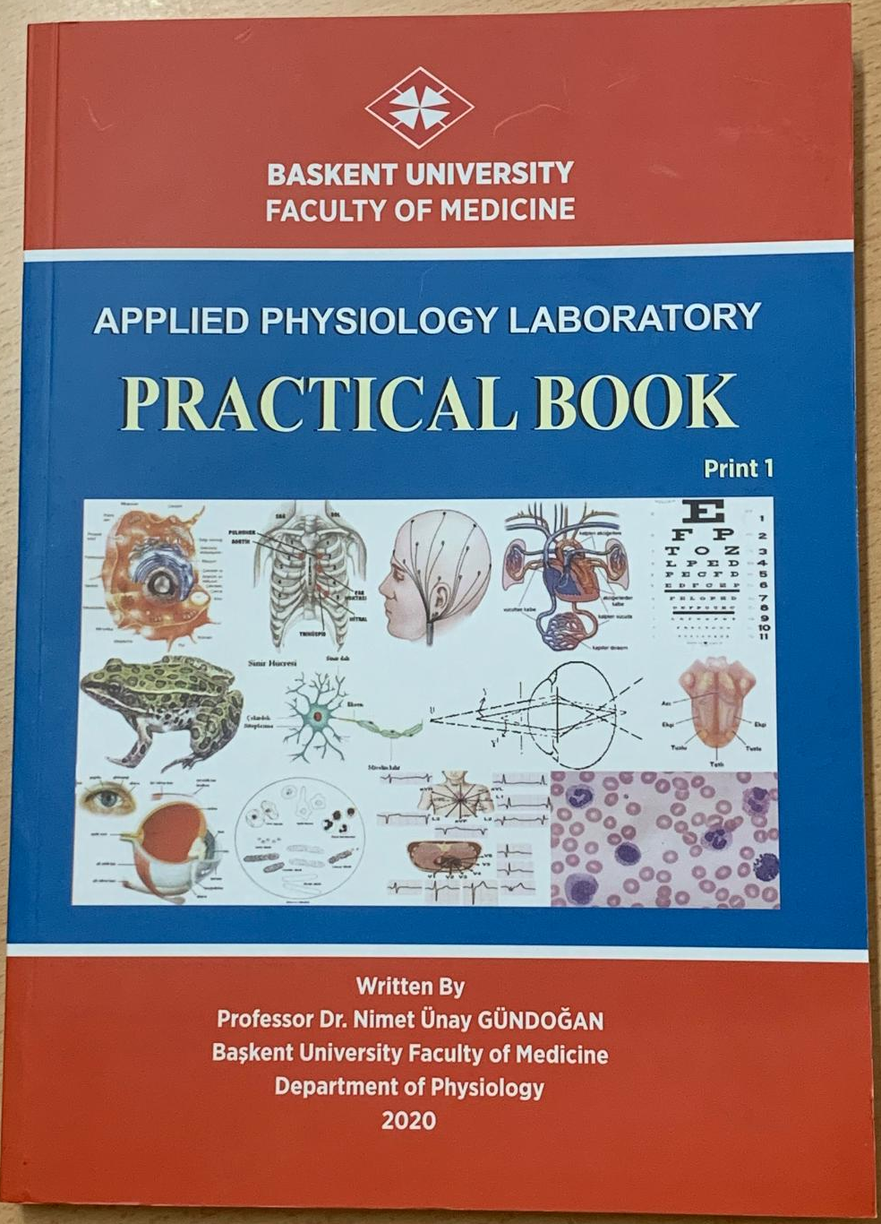
The First English edition of Applied Physiology Laboratory Practical Book published in 2020 for the students of Baskent University Faculty of Medicine for Phase I and Phase II students are ready for selling to students in the in Book Distribution Transportation Address: Baskent University Development Foundation Economic Business Book Store- Book Sales Point.
Bağlıca Kampüsü Fatih Sultan Mahallesi Eskişehir Yolu 18.Km 06790 Etimesgut/ANKARA
Phone: (0312) 246 66 66/ 1166

